Student Life Building
Northampton Community College Monroe Campus
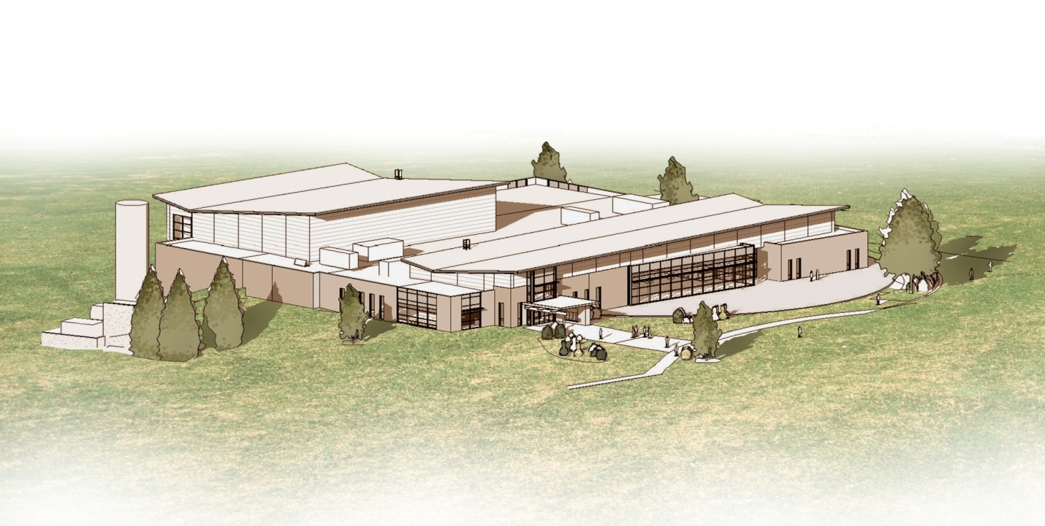

Overview:

Northampton Community College’s Student Life Building is one of three buildings at their new Monroe Campus. The College has seen an influx in enrollment in the past few years and the new campus, sitting on a 71 acre site, will be able to house about 5,000 students. The Student Life Building will function as a cafeteria, gym, fitness center, and have space for club and meeting rooms.

General Building Data
Building Name | Student Life Building
Location | Rt. 715 & Railroad Drive Pocono Township, Monroe County, PA
Occupant | Northampton Community College
Function | Gymnasium, Fitness Center, Cafeteria, Conference Rooms
Size | 68,000 SF
Number of Stories | One story with basement
Dates of Construction | January 2012- January 2014
Project Delivery Method | Design- Bid- Build
Cost | $ 14.5 million

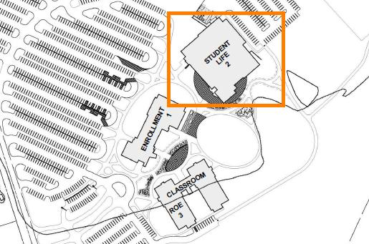

Project Team
Owner | Northampton Community College | http://www.northampton.edu/
Architect | MKSD Architects | http://www.mksdarchitects.com/
Resident Engineer | D’Huy Engineering Inc. | http://www.dhuy.com/
Civil Engineer | Herbert, Rowland, and Grubic Inc. | http://www.hrg-inc.com/hrg_new/index.html
Structural Consultant | Pennoni Associates | http://www.pennoni.com/
MEP Consultant | Strunk-Albert Engineering | http://www.strunk-albert.com/
Food Service Consultant | Clevenger Frable Lavallee Inc. | http://www.cfldesign.com/
Landscape Architect | Derck & Edson Associates | http://www.derckandedson.com/

Architecture

The Student Life Building will be used as an activity center for the college. It’s a one story structure with a full basement. The basement will house mechanical systems and maintenance rooms, and the first floor will be sectioned with the most general spaces – the cafeteria, community room and bookstore – in the front. The fitness center and gym will be located in the back.
Contrasting roof heights and sloped rooflines give the building a very interesting appearance. Instead of the traditional boxy gymnasium, the designers were able to create a visually appealing structure with many different sight lines. Large overhangs…
Design and construction follow IBC 2006 and when doing any work in occupied areas, they will follow ASHRAE 90.1. The building is construction type 2C (noncombustible building structure) and is in group, A-3 (Assembly, Community College Activity Center). There is no historical significance to the site.

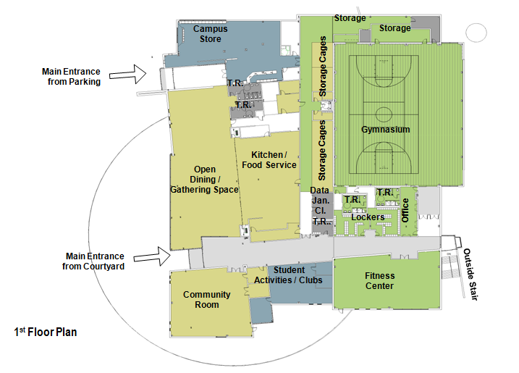

Building Enclosure

Continuity with existing Northampton Community College Campuses is important to the owner. Existing sites have brick and stone finishes, and the Student Life Building will as well. The brick and stone veneer will be broken up with curtain walls and metal paneling. Overhangs and sunshine devices also wrap around the building helping to regulate the sun exposure. The roofing system will be a modified bituminous membrane system that will include a thick layer of insulation under cover the entire roof.

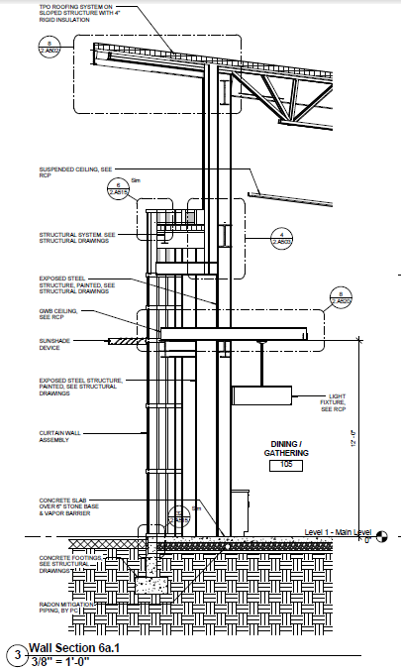

Curtain wall assembly;
The curtain wall assembly will be built with 6065-T5 or T6 aluminum and
the glass itself will be 1” thick- with ½” air space.

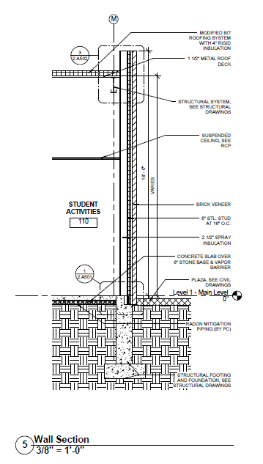

Brick Veneer;
The brick veneer will
be anchored onto cold formed
steel.

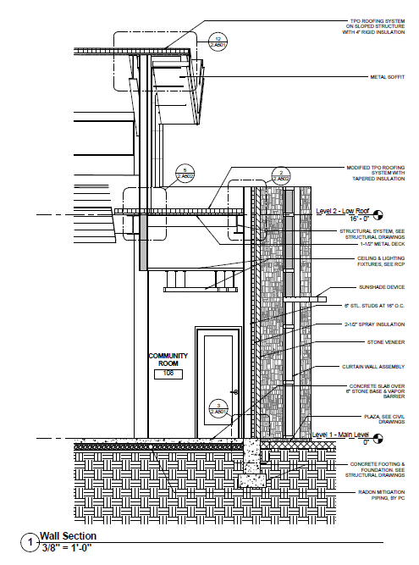

Stone Veneer;
The stone veneer will
be anchored to cold formed
metal framing. Quartz will be
the stone type used.

Sustainability
Northampton Community College is dedicated to sustainability. As a college wide rule, their new construction must all meet silver LEED rating. They plan to reach this goal using a myriad of techniques. There will be sunshade devices and overhangs around much of the building. The Student Life Building will also house the mechanical systems that will distribute chilled and hot water to the other two buildings in the complex. Behind the Student Life Building is a geothermal well field. Two chillers in the building will use these wells to help regulate the water temperature used in the complex’s heating and cooling. This system will greatly reduce college’s energy costs.

